REPORT ON
EFFLUENT CONVEYANCE SYSTEM (M/S ECPL)
FOR NANDESARI INDUSTRIAL AREA AND INDUSTRIES LOCATED NEAR VADODARA, GUJARAT

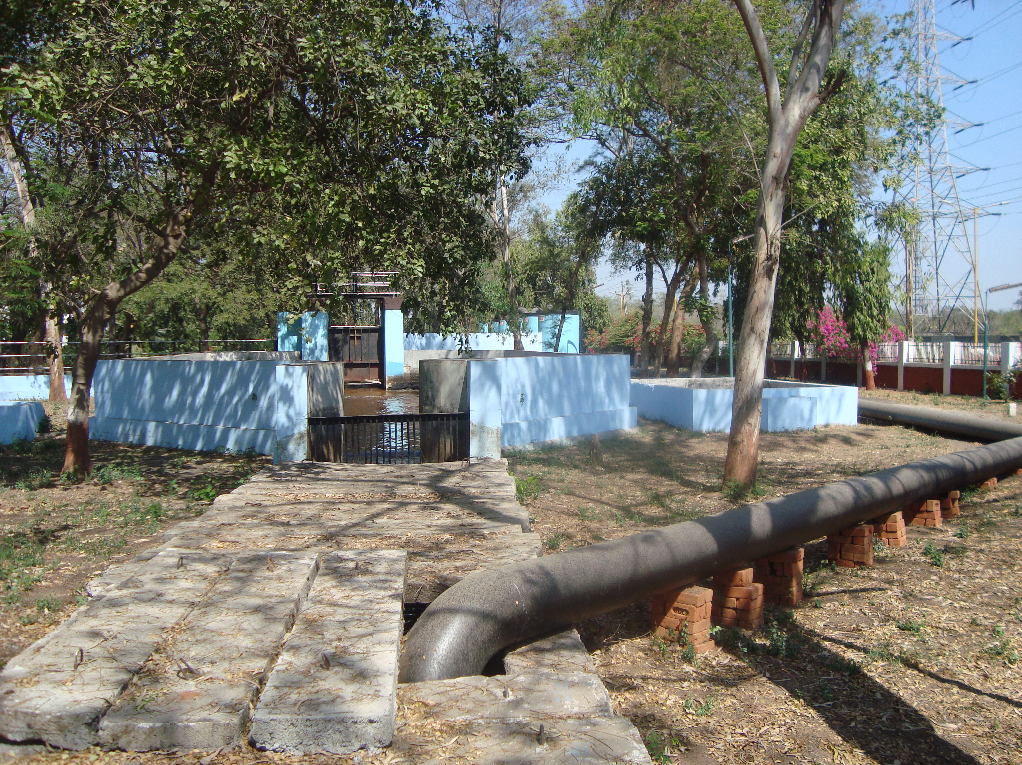
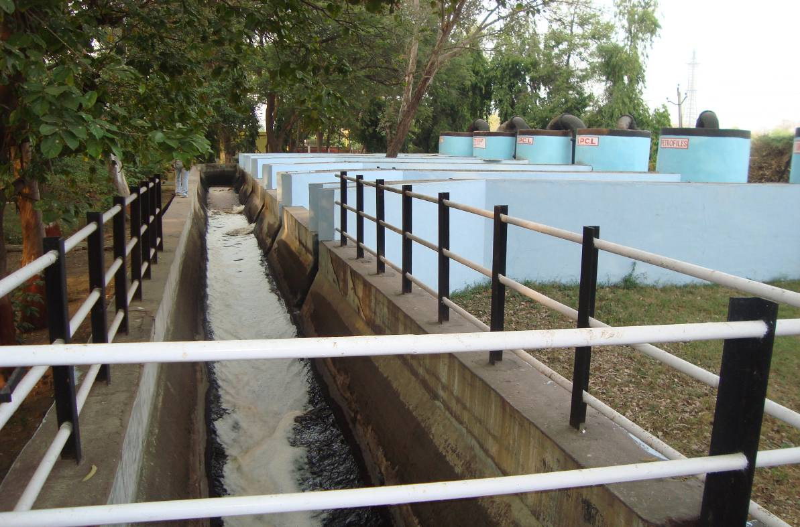

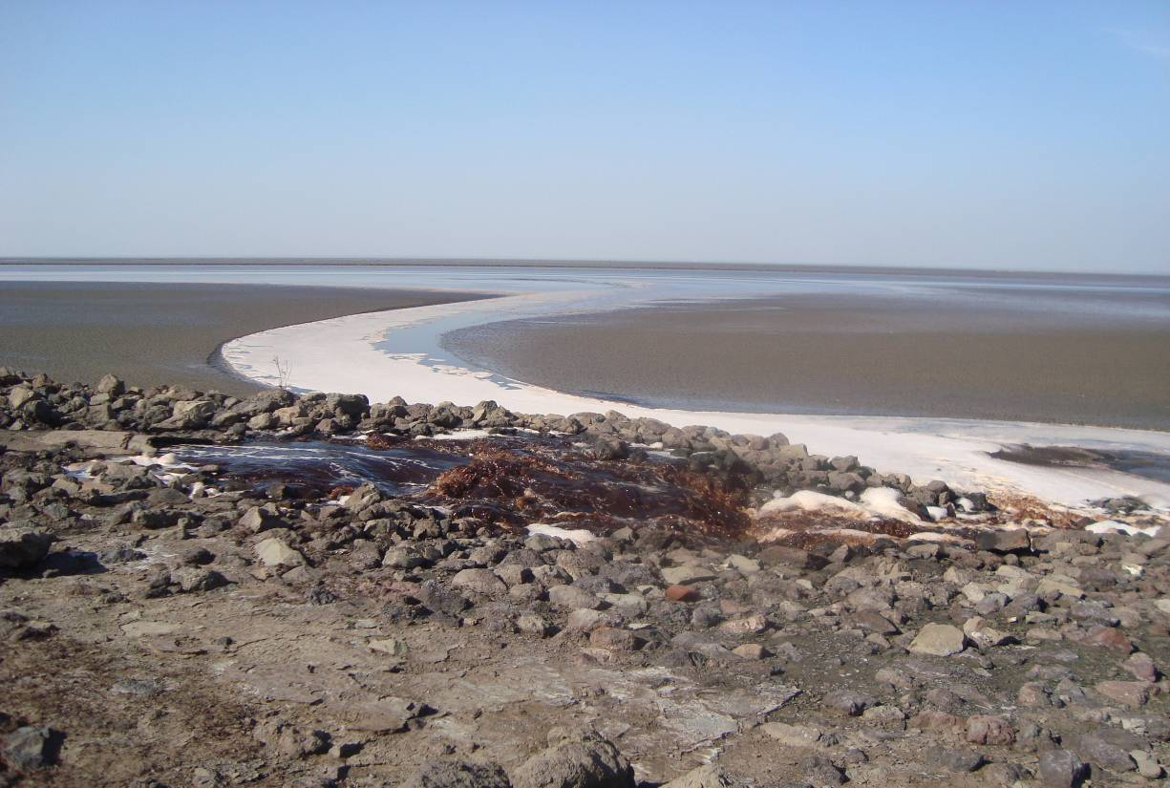
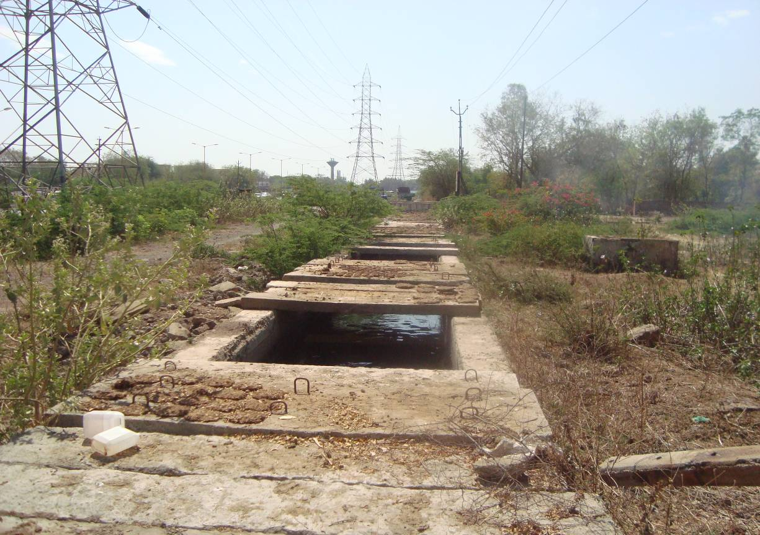

WEST ZONE OFFICE
CENTRAL POLLUTION CONTROL BOARD
Parivesh Bhavan, Subhanpura,
Vadodara-390 023, Gujarat

February 2010

CONTENTS

Sr No |  | Item(s) | Page Nos.
1.0 |  | BACKGROUND | 1
2.0 |  | ABOUT EFFLUENT CHANNEL PROJECT | 1
3.0 |  | ABOUT THE AREA | 2
 | 3.1 | Nandesari Industrial Area | 2
 | 3.1.1 | Common Effluent Treatment Plant (CETP), Nandesari | 3
 | 3.1.2 | CHWTSDF, M/s NECL, Nandesari | 3
 | 3.2 | Industrial Complex in between Nandesari & Vadodara | 3
 | 3.3 | Industries located along Padra & Jambusar Taluka | 3
 | 3.4 | Rivers in the area | 3
4.0 |  | MONITORING | 4
5.0 |  | OBSERVATIONS | 4
6.0 |  | CONCLUSION | 5
7.0 |  | RECOMMENDATIONS | 5
 |  | ANNEXURE | 6-30
Annex- | I | Salient Features of Effluent Channel Project (ECP) | 6
Annex- | II | Location map | 7
Annex- | III A | List of Industries Discharging Effluent into Channel | 8
Annex- | III A | Committed Effluent Quantity and Type of Member Industries | 9
Annex- | IV | GPCB Consolidated Consents & Authorisation (CCA) | 10-16
Annex- | V A | Analysis Results of Monitoring Carried out at M/s ECPL  (in the month of February 2010) | 17
Annex- | V B | Analysis Results of Monitoring Carried out at M/s ECPL  (in the month of March 2008) | 18
Annex- | V C | Effluent Quality at J-Point, Discharge into Estuary of River Mahi, Gulf of Cambay | 19
Annex- | V D | Analysis Results of VOC Monitoring | 20
Annex- | V E | Analysis Results of GPCB Monitoring  (June –December 2009) | 21-25
Annex- | VI | Photographs (1-10) | 26-30

A REPORT ON EFFLUENT CONVEYANCE SYSTEM (M/S ECPL) FOR NANDESARI INDUSTRIAL AREA AND INDUSTRIES LOCATED NEAR VADODARA, GUJARAT

- BACKGROUND:
Effluent Conveyance System called as Effluent Channel Project (ECP) is provided to carry treated effluent from industries (mostly chemical) located near Vadodara to the Gulf of Cambey, Arabian Sea. The industries along the stretch in the area from Padra Taluka (Vadodara District) and Jambusar Taluka (Bharuch District) also join the ECP for effluent discharge. It was reported that quality of effluent at final discharge point always with high organic load, and also not meeting with discharge norms. This may pose serious threat to the environment particularly marine life.

Central Pollution Control Board, West Zone Office, Vadodara carried out effluent monitoring at different points at effluent channel on 18.02.2010 under the Project- VOC Monitoring at Nandesari Industrial Area. The monitoring was carried out for Volatile Organic Compounds (VOC) and other Physico-chemical parameters.

A Monitoring team comprised of following Officials:
- Dr. D. Brahmaiah, Scientist ‘C’, CPCB, Vadodara
- Shri Pratik Bharne, Env Engineer, CPCB, Vadodara
- Shri Sanjiv Vaijnapurkar, Dep Env Engineer, Regional office, GPCB, Vadodara
- Shri Nipendra Semwal, Sr Scientific Assistant, CPCB, Vadodara

- ABOUT EFFLEUNT CHANNEL PROJECT:
A Channel is commissioned (in the year 1983) to carry treated industrial effluent from Industries near Vadodara to estuarine portion of river Mahi, Gulf of Cambay (Khambat). The channel is constructed to prevent discharge of effluent into river Mahi near Vadodara, and hence to prevent the pollution in the River. The channel runs almost parallel to the river.

The channel is 55.30 km long U-shaped brick masonry conduit covered with R.C.C. slab, discharges effluent into estuary of river Mahi (called J point) on down stream of village Sarod, Ta- Jambusar, Dist-Bharuch. The work of lying of closed pipeline is under progress. The design capacity (including free board) is 295 MLD with peak and average flow 145 MLD and 218 MLD respectively. There is no pumping for conveyance of the effluent and natural gradient is available for gravity flow. The salient features of the Effluent Channel Project (ECP) is given at Annexure-I. The location map is provided at Annexure-II.

It starts from Dhanora (called take off point) near Nandesari Industrial Area where it receives treated effluent from industries located in Industrial Complex (in between Vadodara and Nandesari), and other industries at Nandesari through CETP. It receives effluent from IOCL (Oil Refinery) and GSFC (Fertilizer & Chemicals) at Koyali Points (about 2.5 km from Dhanora) and receives effluent from industries along the length. Before discharge at J point, the effluent is passed though Holding Lagoon (two lagoons, one stand by, capacity of each 18.12 MLD, (Please, refer Annexure-VI, Photographs: 06-07). In all 46 industries have become members of this facility, out of which 34 member industries are discharging effluent into ECP at present.

It receives effluent in following way (please refer location map, Annexure-II):
- At Dhanora Take off Point, Premises M/ ECPL (Please, refer Annexure-VI, Photographs:01-03):
-Inlet Sump PS-I: Effluent from Pumping Station-I (PS-I) i.e. effluent from CETP, and industries such as Deepak Nitrate, Indo Nippon and Ineous ABS
-Inlet Sump PS-II: Effluent from Pumping Station-II (PS-II) i.e. effluent from industries such as GACL, GPPL, Jayant Agrochem, GSFC (polymer), DACL etc
-Inlet Sump- RIL (IPCL): Effluent from Reliance Industries Ltd.,
- At Koyali Point (Please, refer Annexure-VI, Photographs:5) : Inlet Sump (GSFC), Inlet Sump (IOCL) i.e. effluent from GSFC (Fertilizers & Chemicals), IOCL
- Along the length: Industries from Padra Taluka of Vadodara district and Jambusar Taluka of Bharuch districts ( mostly chemical industries -Pharmaceuticals, Dye & Dyes Intermediate etc)

The list of member industries discharging their effluent into Inlet Sumps at Dhanora Take of Points, Koyali Point and along the length etc is given in Annexure-III A. Committed effluent quantity and type of member industries are given in Annexure-III B.

The channel is operated and maintained by Effluent Channel Project Ltd (ECPL), a company incorporated under the Company Act, 1956 on 20.11.1999. The Company has board of directors from different member industries with Chairman from Gujarat Industrial Development Corporation (GIDC). It is claimed that it is first effluent disposal channel for safe disposal of treated industrial effluent on co-operative basis. The fund is mobilized through capital contribution from industries during the joining, annual maintenance & operation charges based on committed quantity of effluent and surcharge as applicable based on distance from Dhanora Take of Point. ECPL earns consultancy fees by rendering Scientific & Engineering Services to outside agencies, member industries etc. In addition, ECPL earn interest on available fund, and maintenance of road parallel to ECPL carried out through toll tax collection

M/s ECPL has obtained Consolidated Consents & Authorisation (CCA), attached as Annexure-IV, from Gujarat Pollution Control Board which is valid up to 13.09.2010 for use of treated effluent conveyance system (Effluent Channel project) for collection of treated effluent from member industrial units and final discharge of treated effluent into estuary of river Mahi.

- ABOUT THE AREA:
  - Nandesari Industrial Area:
It is developed by GIDC in the year 1969, is located about 17 Kms in the northwest direction of Vadodara City (Please, refer Annexure-II for location map). Nandesari GIDC estate, with an area approx. 2.5 sq.km, mainly comprises of chemical industries. It has common environmental infrastructure facilities like CETP, CHWTSDF (Landfill as well as Common Hazardous Waste Incinerator).
The industrial statistics of Nandesari Industrial Area is given in following table:

Type/Sector of Industries | Nos.
Chemical (Organic & Inorganic) | 100
Dyes Intermediate & Dyes | 40
Pharmaceutical (Bulk Drug and Formulation) | 15
Pesticides (Technical Grade & Formulation) | 04
Others | 11
Total | 170
Large & Medium Scale | 20
Small Scale | 150
    - Common Effluent Treatment Plant (CETP):

CETP is established by GIDC in the year 1984 for the treatment of mostly small scale industries. Nandesari Industries Association (NIA) took over operation and maintenance of CETP in November 1994. The design capacity is 5.5 MLD and average inflow is about 2.0 MLD. The effluent received through dedicated tankers from member industries (170). Domestic wastewater (~150 KLD) from colony is added to aeration tank. The CETP consists of primary, secondary and tertiary treatment. The treatment units are Collection Sumps, Screen Chamber, Grit Chamber, Equalisation tank, Flash Mixer, Flocculator, Primary Clarifier, Aeration Tank, Secondary Clarifier, Hypo Treatment Unit, and Pressure Sand Filter.

CETP discharges (2250 KLD) its treated effluent along with treated effluent from M/s Deepak Nitrate (1300 KLD), M/s Indo Nippon (50 KLD), M/s Ineous ABS (1000 KLD) into Pumping Station—I at Dhanora Take off Point, ECPL.

    - Common Hazardous Waste Treatment Storage Disposal facility (CHWTSDF):
CHWTSDF is developed by M/s Nandesari Environ Control Ltd (NECL), a company formed by Nandesari Industries Association and member industries for the disposal of hazardous waste. The facility has landfill and incineration facility.

The first cell, second cell and third cell of TSDF were commissioned in 1999, 2003 and 2008 respectively. Two cells (first & second) are closed. About 1,33,000 MT hazardous waste were disposed in these two cells. In third cell (design capacity 3,00,000 MT) about 30651 MT waste is disposed till September 2009. The members of the facility are 703 i.e. GIDC Nandesari- 216, Outside Nandesari- 487. The incinerators as well as storage area are not as per the CPCB guidelines.

  - Industrial Complex in between Vadodara and Nandesari:
Almost in between Vadodara and Nandesari, major industries such as Indian Oil Corporation Ltd (Oil Refinery), Reliance Industries Ltd (Petrochemical, formerly Indian Petrochemical Corporation Ltd (IPCL)), Gujarat Alkali Company Ltd (Chloralkali), Gujarat State Fertilizer Corporation ( Fertilizers, Chemicals, Polymers) etc are located.

  - Industries located along ECP in Padra & Jambusar Taluka:
Mostly, Dyes & Dyes Intermediate, Pharmaceuticals (Bulk drugs, formulations) are located, almost along ECP, sporadically in the Padra Taluka of Vadodara Districts and Jambusar Taluka of Bharuch District. This area is also known as vegetable basket with good fertile agricultural land.

  - Rivers in the Area:
Major river- Mahi is traversed from north side Vadodara, Nandesari and ultimately meets to Gulf of Cambey, Arabian Sea. This river is a major water supply source for industrial as well as domestic purpose. A dam is constructed in the upstream direction at Kadana on this river. The ECP runs almost parallel to this river.

A small river, called Mini, is passed in-between Nandesari Industrial Area and industrial complex comprising IOCL, RIL, GACL etc. The Miniriver meets River Mahisagar. The river receives industrial as well as domestic wastewater in the downstream of industrial area mostly storm water drain passed through IOCL.

- MONITRING:
CPCB, West Zone, Office, Vadodara has carried out effluent monitoring on 18.02.2010. The samples were collected, on grab basis, at Dhanora Take Off Point, Koyali Point to see effluent quality discharging in to ECP through individual inlet sumps, and from Channel at three locations along the stretch. The details of sampling locations and analysis results are given in Annexure- V (A). Sampling locations are also shown in location map placed as Annexure-II.

The ECP was also monitored earlier under a project, by the Student of Environmental Science Programme, the M.S. University of Baroda, Vadodara with CPCB, West Zone Office, Vadodara. The monitoring was carried out in the month March 2008. The details of the sampling locations and analysis results are given in Annexure-V (B).

The effluent quality at J-Point which was discharged into estuary of river Mahi during year 2008 and 2010 is given in Annexure-V (C).

The VOC monitoring results are given at Annexure-V (D).

- OBSERVATIONS:
Following observations are made based on the visit and monitoring results (Please, refer Annexure-V (A, B, C & D):
- Analysis results of the sample, collected from Inlet Sump PS-I where the effluent from CETP, and industries such as Deepak Nitrate, Indo Nippon and Ineous ABS, show that the concentration of all the analysed parameters exceeds the GPCB norms. For other inlet sumps, the concentrations are found within the norms.

- The concentrations of almost all parameters are observed to be increasing along the channel towards the end of the channel.

- The concentration is increasing due to joining of effluent from the industries located along the ECP channel from Padra Taluka, Jambusar Taluka. The industries are located in the stretch Lakdikui to Mujpur and Karkhadi to Vedach villages.

- Except BOD at first two locations along the ECP, the concentrations of all analysed parameters are exceeding the GPCB norms.

- The effluent which was being discharged into estuary of river Mahi shows pH: 4.60 (6.5-8.5), TSS: 361 (100) mg/l, TDS: 14458 (5000) mg/l, COD: 1826 (250) mg/l, BOD: 334 (100) mg/l, NH₃-N: 387 (50) mg/l, Cyanide: 2.857 (0.2) mg/l and Phenols: 15.37 (1.0) mg/l. The value in parenthesis shows GPCB norm.

- These concentrations show gross violation of GPCB norms under the Water Act, 1974. The concentrations are 3 to 15 times more than the GPCB discharge norms. The concentration of COD, BOD, NH₃-N, Cyanide and Phenols are 7.3, 3.3, 7.74, 14.3 and 15.37 times more than the GPCB norms.

- As observed from analysis results, most detected VOCs along the ECP are Chloroform, 1,2-Dichloroethane and Toluene. Near Mujpur village crossing i.e. ECP-2, Benzene concentration is 104 µg/m³.

- As observed from the monitoring during the year 2008, the concentration of parameters near village Vedach show maximum concentration along the length of ECP.
The concentration of most of the analysed parameters exceeds the norms prescribed by GPCB. The pH was found 1.1 at J –Point during the monitoring on 10.03.2008.

- The concentration of effluent which was being discharged into estuary of river Mahi, at J-Point shows gross non-compliance with GPCB norms for all analysed parameters- pH, TSS, TDS, COD, BOD, NH₃-N, Chlorides, Phenols and Cyanide during the monitoring in the year 2008 as well as 2010.

- As per the GPCB monthly monitoring results, for the period January 2009-Decemeber 2009, the quality of effluent discharged at J point shows the concentrations in the range:- Colour:250-1400 Platinum Cobalt Scale, BOD:316-900 mg/l, COD: 1126-3216 mg/l, NH3-N: 19.04-285.6 mg/l. The results of monitoring carried out by GPCB at Inlet Sump PS-I, Inlet Sump PS-II, Mix Effluent At Dhanora, Mix Effluent at Koyali and J-Point (Final Point) is given at Annexure-V (E).

- The effluent is not discharged into estuary of river Mahi during high tide; instead it gets retain at Lagoons.

- The quality of the effluent discharged into the environment is no way better than that of the effluent discharged by FETP, Ankleshwar or CETP, Vapi.

- The RCC slabs on the Channel was found missing at some locations along the length. The work of lying of closed pipeline was observed near the J point.

- It was observed some years back and also reported that the effluent is used for agriculture purpose. But, this practice seems to be now reduced due to freshwater canal flowing parallel to ECP, on other side of the road.

- CONCLUSION:

It can be concluded that the effluent carried by Channel (ECP) and discharge at estuary of river Mahi, Gulf of Cambey not meeting with GPCB prescribed discharge norms. The concentrations of analysed pollutants are 3 to 15 times more than the norms for different pollutants. The quality of effluent deteriorates along the channel towards its end suspecting downstream industries are discharging its effluent even without treatment.

ECP should discharge effluent after treatment and meeting with the GPCB norms, as per CCA, Specific Conditions (No.2), Sub Serial No 18 & 20. However, at present, no treatment is provided to the effluent carried by channel.

- RECOMMONDATIONS:

- M/s ECPL may be directed to comply with CCA conditions particularly for non-compliance of prescribed discharge norms.
- Suitable common treatment system should be provided near present Lagoons (near J Point) so as to meet the GPCB norms, and CCA Specific Conditions (No.2), Sub Sr No. 18 & 20.
- Constant monitoring and watch by GPCB/ECPL on the industries (particularly those located along the ECP from Padra Taluka and Jambusar Taluka)
- Strict actions against the defaulter industries.
- Proper disposal point may be identified deep into the Gulf of Cambay by carrying out study by NIO.
- Avoid the use of effluent from channel for agriculture purpose.

(Pratik D. Bharne)
Env Enginner

Annexure-I

SALIENT FEAUTURES OF EFFLUENT CHANNEL PROJECT LIMITED (ECPL)
(As provided by M/ ECPL, Vadodara)

Items | Information
Capacity of Channel: | Qty in MGD | Qty in MLD
Average Flow | 32.00 | 145.00
Peak Flow (1.5 times average) | 48.00 | 218.00
Capacity including free board | 65.00 | 295.00
Effluent Channel:
Length of the Channel | 55.30Kms
Section of the Channel | “U” shape brick masonry conduit covered with RCC slabs
Depth of flow at peak discharge of 48.00 MGD | 1.65M
Gradient of the Channel | 1 in 3000
C D Works:
Classified village Road Bridge | 19 Nos.
Unclassified village Road Bridge | 106 Nos.
Aquaduct | 2 Nos.
Siphon | 10 Nos.
Slab Drain | 2 Nos.
TOTAL | 139 Nos
In addition of above C D works No of falls provided | 6 Nos.
(A) HOLDING LAGOON (2 nos)
1. Capacity of each holding lagoon | 4.00 MGD (18.125 MLD)
2. Dimension of the Lagoon
At Top | 94.00 x 143.00 m
At Bottom | 69.00 x 118.00 m
Inspection Road
5.20/3.66 m wide Asphalted Road of 56 kms in length
Land Acquisition :
Width of Land Strip | 15.00 m wide

Annexure-III A

LIST OF INDUSTRIES DISCHARGING EFFLUENT INTO CHANNEL-M/s ECPL

Sr. No. | Name of Industries | Receiving Sumps/Points
1 | Members of CETP -Nandesari Industries Association (NIA) | Dhanora (Take Off Point)  Inlet Sump PS - I
2 | INEOS ABS Ltd | Dhanora (Take Off Point)  Inlet Sump PS - I
3 | Gujarat Alkalies and Chemicals Ltd. (GACL) | Dhanora (Take Off Point)  Inlet Sump PS - II
4 | Gujarat State Fertilizers and Chemicals Ltd. (Polymers Unit) | Dhanora (Take Off Point)  Inlet Sump PS - II
5 | Diamines and Chemicals Ltd (DACL) | Dhanora (Take Off Point)  Inlet Sump PS - II
6 | Gujarat Polybutene Pvt Ltd (GPPL) | Dhanora (Take Off Point)  Inlet Sump PS - II
7 | Jayant Agro-Organic Ltd | Dhanora (Take Off Point)  Inlet Sump PS - II
8 | Reliance Industries Ltd | Dhanora (Take Off Point)  Inlet Sump-RIL(IPCL)
9 | Ihsedu Specialty Chemicals Pvt. Ltd | Channel Near Dhanora
10 | Gujarat Industries Power Company Ltd (GIPCL) | Channel Near Dhanora
11 | Gujarat State Fertilizers and Chemicals Ltd. (GSFC) | Koyali Point
12 | Indian Oil Corporation Ltd. (IOCL) | Koyali Point
13 | Prasad International Pvt. Ltd. | Channel approx between villages- Lakdikui to Mujpur  (Zone II Ekalbara)
14 | Baroda Textile Effects Pvt. Ltd (BTEPL)
15 | Loxim Industries Ltd.
16 | Bodal Chemicals Ltd (Unil – VIII)
17 | Enviro Infrastructure Co. Ltd. (EICL)
18 | Refoil Earth Pvt. Ltd.
19 | Kabra Colours Pvt. Ltd.
20 | Transpek Industry Ltd.
21 | Biotor Industries Ltd.
22 | S.A. Pharmachem Pvt. Ltd
23 | Jain Irrigation Systems Ltd.
24 | Kadillac Chemicals Pvt. Ltd. | Channel approx between villages- Karkhadi to Vedach  (Zone III Karkhadi)
25 | TML Industries Ltd. (Karkhadi)
26 | Best Value Chem (P) Ltd.
27 | Sterling Gelatin
28 | Mayur Dye Chem. Intermediate Ltd.
29 | Asahi Songwon Colors Ltd.
30 | Lonsen Kiri Chemicals Industries Ltd.
31 | Kiri Dyes and Chemicals Industries Ltd. (Main Unit)
32 | Bodal Chemicals Ltd. (Unit I VII)
33 | Sterling Biotech Ltd.
34 | TML Industries Ltd. (Piludra)

Annexure-III B

COMMITTED EFFLUENT QUANTITY AND TYPE OF MEMBER INDUSTRIES OF M/s ECPL

Sr. No. | Name of Industries | Committed Treated Effluent Quantity  (in MGD) | Type of Industry
1 | CETP Members- Nandesari Industries Association (NIA) | 0.750 | Common ETP
2 | INEOS ABS Ltd. | 0.138 | Plastic Resin
3 | Gujarat Alkalies and Chemicals Ltd. (GACL) | 0.733 | Chemical
4 | Gujarat State Fertilizers and Chemicals Ltd. (Polymers Unit) | 0.175 | Polymers
5 | Diamines and Chemicals Ltd. (DACL) | 0.013 | Chemical
6 | Gujarat Polybutene Pvt. Ltd. (GPPL) | 0.031 | Chemical
7 | Jayant Agro-Organic Ltd. | 0.005 | Agro chemicals
8 | Reliance Industries Ltd. | 3.500 | Petrochemicals
9 | Ihsedu Speciality Chemicals Pvt. Ltd. | 0.066 | Chemical
10 | Gujarat Industries Power Company Ltd. (GIPCL) | 0.350 | Power Project
11 | Gujarat State Fertilizers and Chemicals Ltd. (GSFC) | 3.000 | Chem. Fertilizers Co.
12 | Indian Oil Corporation Ltd. (IOCL) | 0.700 | Petrochemicals
13 | Prasad International Pvt. Ltd. | 0.003 | Dyes Intermediate
14 | Baroda Textile Effects Pvt. Ltd. (BTEPL) | 0.176 | Dyes Intermediate
15 | Loxim Industries Ltd. | 0.022 | Dyes Intermediate
16 | Bodal Chemicals Ltd. (Unit - VIII) | 0.022 | Dyes Intermediate
17 | Enviro Infrastructure Co. Ltd. (EICL) | 0.100 | Common ETP
18 | Refoil Earth Pvt. Ltd. | 0.009 | Chemical
19 | Kabra Colours Pvt. Ltd. | 0.005 | Dyes Intermediate
20 | Transpek Industry Ltd. | 0.072 | Chemical
21 | Biotor Industries Ltd. | 0.110 | Agro chemicals
22 | S.A. Pharmachem Pvt. Ltd. | 0.023 | Pharmaceuticals
23 | Jain Irrigation Systems Ltd. | 0.066 | Food Product
24 | Kadillac Chemicals Pvt. Ltd. | 0.022 | Chemical
25 | TML Industries Ltd. (Karkhadi) | 0.010 | Chemical
26 | Best Value Chem (P) Ltd. | 0.004 | Chemical
27 | Sterling Gelatin | 1.138 | Chemical
28 | Mayur Dye Chem. Intermediate Ltd. | 0.006 | Dyes Intermediate
29 | Asahi Songwon Colors Ltd. | 0.073 | Pigment
30 | Lonsen Kiri Chemicals Industries Ltd. | 0.055 | Dyes Intermediate
31 | Kiri Dyes and Chemicals Ltd. (Main Unit) | 0.066 | Dyes Intermediate
32 | Bodal Chemicals Ltd. (Unit - VII) | 0.292 | Dyes Intermediate
33 | Sterling Biotech Ltd. | 0.132 | Pharmaceuticals
34 | TML Industries Ltd. (Piludra) | 0.015 | Chemical
 | Total | 11.882

Annexure-V (A)
CENTRAL POLUTION CONTROL BOARD,
West Zone Office, Vadodara
ANALYSIS RESULTS OF MONITORING CARRIED OUT AT M/ ECPL
Date of Sampling: 18.02.2010 Type of Sampling: Grab
 | Sampling Location(s) | pH | TSS | TDS | COD | BOD | NH₃-N | TKN | Cl⁻ | CN⁻ | Phenols
Inlets to ECP
Dhanora (Take Off Point), ECP | Inlet Sump PS-I | 7.22 | 238 | 14616 | 691 | 137 | 443 | 473 | 7139 | 0.414 | 6.80
Dhanora (Take Off Point), ECP | Inlet Sump PS-2 | 7.35 | 27 | 3253 | 89 | 17 | 3.8 | 6.32 | 1391 | 0.105 | 2.42
Dhanora (Take Off Point), ECP | Inlet Sump RIL (IPCL) 1 & 2 | 9.56 | 69 | 2273 | 68 | 9.7 | 10.6 | 12.2 | 942 | 0.014 | 1.243
Koyali Point (@ 2.5 from Dhanora) | Inlet Sump GSFC | 7.72 | 39 | 2446 | 185 | 41 | 20 | 32 | 734 | 0.063 | 1.11
Along the ECP | ECP-1,  Just after Dhanora Take Off Point i.e. Start of Channel (Mix effluent from PS-I, PS-II & RIL ) | 7.88 | 129 | 6709 | 423 | 50 | 177 | 189 | 3100 | 0.856 | 3.92
Along the ECP | ECP-2,  Near Mujpur Village crossing (@ 20 km d/s of Dhanora Take off Point) | 7.58 | 94 | 5481 | 611 | 57 | 195 | 217 | 2136 | 0.793 | 12.76
Along the ECP | ECP-3,  J-Point (Final discharge Point, end of Channel, @ 55 km from d/s of Dhanora Take off Point ) | 4.60 | 361 | 14458 | 1826 | 334 | 387 | 419 | 3665 | 2.857 | 15.37
GPCB Norms |  | 6.5-8.5 | 100 | 5000 | 250 | 100 | 50 | -- | 600 | 0.2 | 1.0
Note: Except pH, all other results expressed in mg/L.

Annexure-V (B)
CENTRAL POLUTION CONTROL BOARD,
West Zone Office, Vadodara
ANALYSIS RESULTS OF MONITORING CARRIED OUT AT M/ ECPL

Date of sample collection: 10.03.2008, 27.03.2008, 28.03.2008 Type of sample collection: Grab

Sampling Location(s) | Date of Sampling | pH | TSS | COD | BOD | NH₃-N | TKN | Cl⁻ | CN⁻ | Phenols
@ 2 kms downstream from start of Channel (ECP), Dhanora Take off Point | 10.03.2008 | 7.44 | 63 | 338 | 47 | 35 | 59 | 1797 | 0.03 | 0.20
 | 27.03.2008, night time | 7.7 | 69 | 407 | 25 | 35 | 39 | 1580 | 0.08 | 0.71
 | 28.03.2008, morning time | 7.1 | 54 | 357 | 28 | 13 | 50 | 1602 | 0.11 | 1.52
 | 28.03.2008, afternoon | 7.0 | 77 | 594 | 26 | 50 | 82 | 2753 | 0.15 | 8.23
@9 kms downstream from Dhanora Take off Point | 10.03.2008 | 8.01 | 55 | 247 | 42 | 35 | 51 | 876 | 0.02 | 0.29
@9 kms downstream from Dhanora Take off Point | 27.03.2008, night time | 7.0 | 79 | 428 | 21 | 51 | 65 | 2572 | 0.011 | 0.43
@9 kms downstream from Dhanora Take off Point | 28.03.2008, morning time | 8.1 | 117 | 1667 | 76 | 57 | 67 | 2414 | 0.16 | 18.67
@9 kms downstream from Dhanora Take off Point | 28.03.2008, afternoon | 8.6 | 141 | 1806 | 184 | 81 | 235 | 4062 | 0.23 | 21.87
Near village Vedach (2 kms upward) @ 36 km from Dhanora Take off Point | 10.03.2008 | 7.75 | 135 | 784 | 243 | 112 | 126 | 2879 | 0.02 | 0.34
 | 27.03.2008, night time | 2.1 | 94 | 1600 | 109 | 49 | 93 | 2617 | 0.01 | 0.82
 | 28.03.2008, morning time | 2.6 | 115 | 4216 | 1320 | 134 | 152 | 4535 | 0.03 | 1.22
 | 28.03.2008, afternoon | 3.8 | 476 | 2083 | 492 | 127 | 148 | 3136 | 0.001 | 0.960
J point, End of Channel (ECP) @ 55 Km from Dhanora Take Off Point, effluent discharging into estuary of river Mahi, Gulf of Cambay | 10.03.2008 | 1.1 | 193 | 1490 | 254 | 96 | 171 | 6543 | 0.80 | 0.58
 | 27.03.2008, night time | 7.0 | 540 | 941 | 163 | 149 | 171 | 3746 | 0.05 | 4.12
 | 28.03.2008, morning time | 3.4 | 480 | 2419 | 343 | 61 | 87 | 30263 | 0.06 | 5.88
 | 28.03.2008, afternoon | 4.8 | 560 | 1776 | 219 | 79.0 | 105 | 2256 | 0.07 | 2.10
GPCB Norms |  | 6.5-8.5 | 100 | 250 | 100 | 50 | -- | 600 | 0.2 | 1.0

Note: Except pH, all other results expressed in mg/L.
Annexure-V (C )
CENTRAL POLUTION CONTROL BOARD,
West Zone Office, Vadodara
EFFLUENT QUALITY AT J-POINT, END OF ECP, DISCHARGE INTO ESTURY OF RIVER MAHI, GULF OF CAMBAY

Sampling Location(s) | Year of Monitoring | Date of Sampling | pH | TSS | COD | BOD | NH₃-N | TKN | Cl⁻ | CN⁻ | Phenols
J point, End of Channel (ECP) @ 55 Km from Dhanora Take Off Point, effluent discharging into estuary of river Mahi, Gulf of Cambay | 2008 | 10.03.2008 | 1.1 | 193 | 1490 | 254 | 96 | 171 | 6543 | 0.80 | 0.58
 | 2008 | 27.03.2008, night time | 7.0 | 540 | 941 | 163 | 149 | 171 | 3746 | 0.05 | 4.12
 | 2008 | 28.03.2008, morning time | 3.4 | 480 | 2419 | 343 | 61 | 87 | 30263 | 0.06 | 5.88
 | 2008 | 28.03.2008, afternoon time | 4.8 | 560 | 1776 | 219 | 79.0 | 105 | 2256 | 0.07 | 2.10
 | 2010 | 18.02.2010 | 4.6 | 361 | 1826 | 334 | 387 | 419 | 3665 | 2.86 | 15.37
GPCB Norms |  |  | 6.5-8.5 | 100 | 250 | 100 | 50 | -- | 600 | 0.2 | 1.0

Annexure-V (D)
CENTRAL POLUTION CONTROL BOARD,
West Zone Office, Vadodara
ANALYSIS RESULTS FOR VOLLATILE ORGANIC COMPUNDS (VOCs)
(Sampling and Analysis carried out by M/s SGS India Pvt Ltd, Chennai)

Sampling Location | Benzene | Bromo dichloro methane | Carbon tetra chloride | Chloro benzene | Chloroform | 2-Chloro toluene | 4-Chloro toluene | 1,2-Dichloroethane | Toluene | p-Isopropyl toluene | Total VOC
Inlet to ECP
Inlet Sump PS-1,  Dhanora Take Off Point | -- | 8.7 | -- | 25.4 | 1250.8 | -- | -- | 1645.9 | 9.1 | 352.1 | 3292.1
Inlet Sump PS-2,  Dhanora Take Off Point | -- | 1.90 | 25.50 | -- | 356.30 | -- | -- | -- | -- | -- | 383.70
Inlet Sump RIL,  Dhanora Take off point | -- | -- | -- | -- | -- | -- | -- | 81.0 | -- | -- | 81.0
Inlet Sump GSFC,  Koyali Point | -- | -- | -- | -- | -- | -- | -- | -- | -- | -- | <1
Along the ECP Channel
ECP – 1, Just after Dhanora Take Off Point i.e. Start of Channel (Mix effluent from PS-I, PS-II & RIL ) | -- | -- | 2.1 | 5.0 | 822.5 | 13.6 | 14.1 | 563.1 | 2.2 | -- | 1422.6
ECP-2, Near Mujpur Village crossing (@ 20 km d/s of Dhanora Take off Point) | 104.0 | -- | -- | 5.0 | 257.5 | -- | -- | 300.2 | 24.7 | -- | 695.4
ECP-3, J-Point (Final discharge Point, end of Channel, @ 55 km from d/s of Dhanora Take off Point ) | -- | -- | -- | 159.0 | 129.1 | -- | -- | 1094.9 | 3.6 | -- | 1381.6

Annexure-VI
Dhanora (Take of Point), Inlet Sumps (PS-1, PS-2, RIL),
(Photographs taken on 18.02.2010)
Photo-01

Photo-02
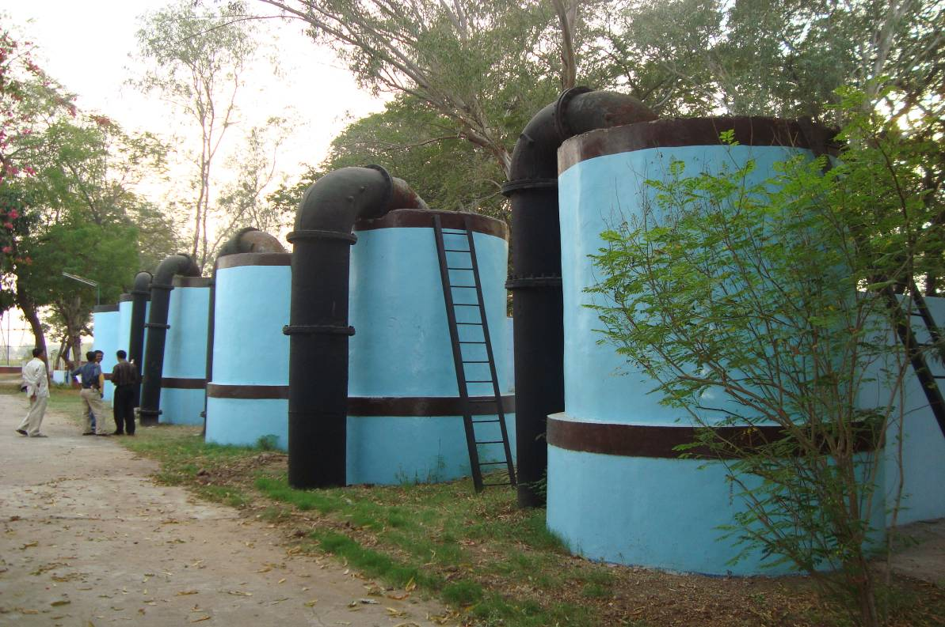

Photo-03, Dhanora (Take Off Point), Start of Channel (ECP)

Photo-04, ECP just after Dhanora Take off Point

Photo-05, Koyali Point (Inlet Sumps of GSFC, IOCL)
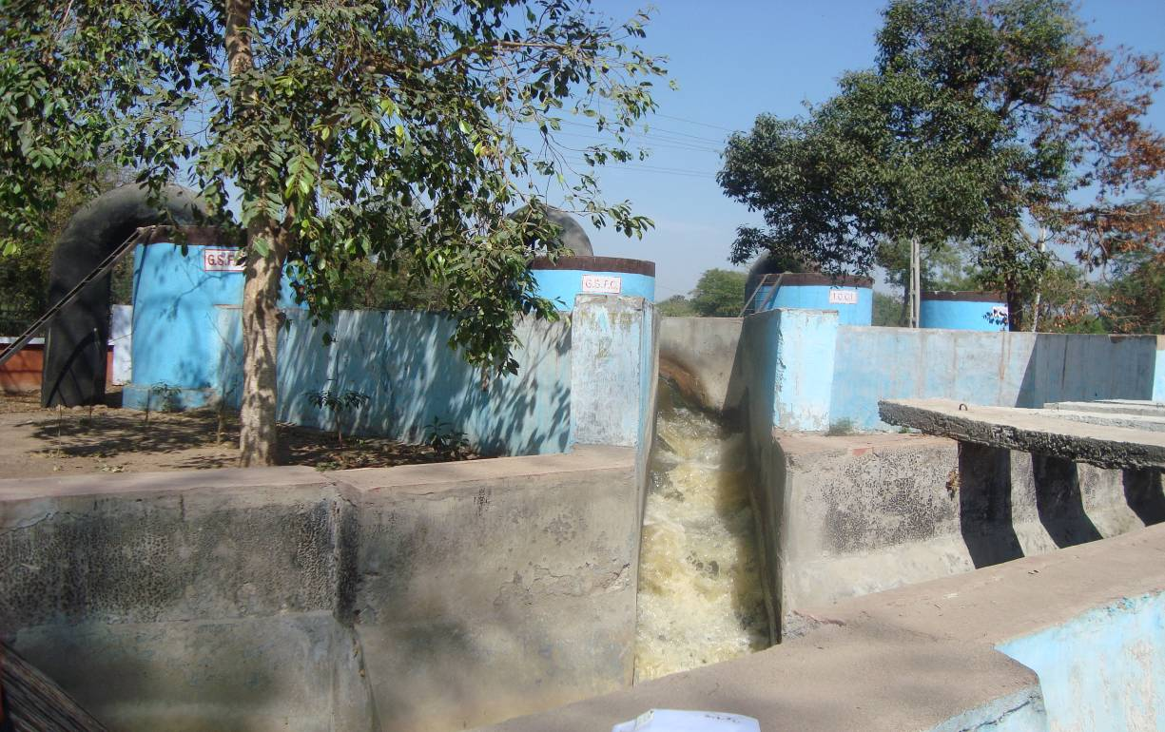

Photo-06, Lagoon near J Point , before discharge of effluent
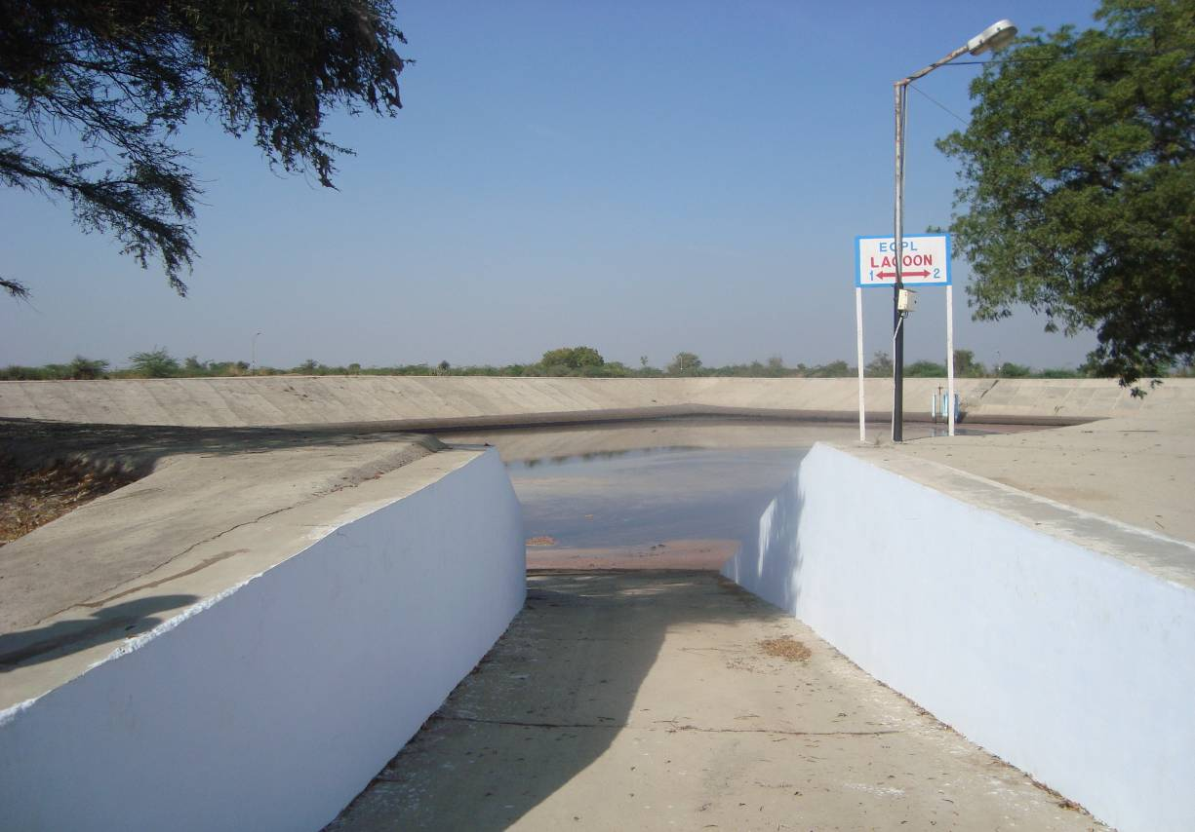

Photo-07, Lagoon near J-Point
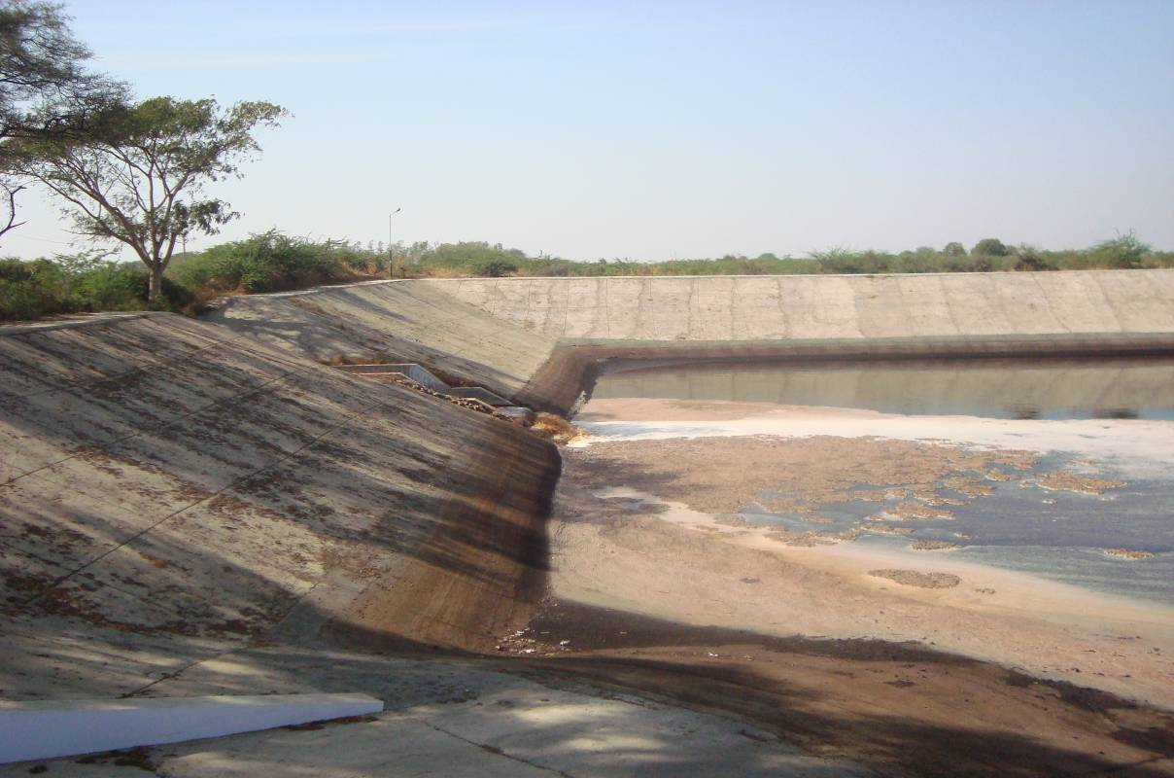

Photo-08, J-Point, End of ECP, Estuarine of Mahi river, Gulf of Cambay
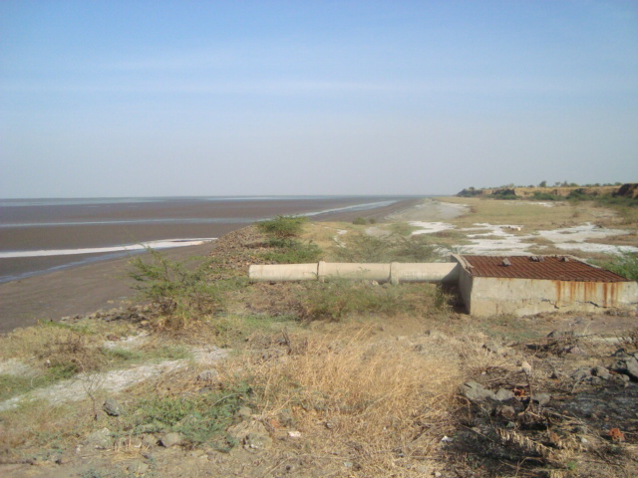

Photo-09, Effluent discharge into estuarine portion of river Mahi (at J Point)
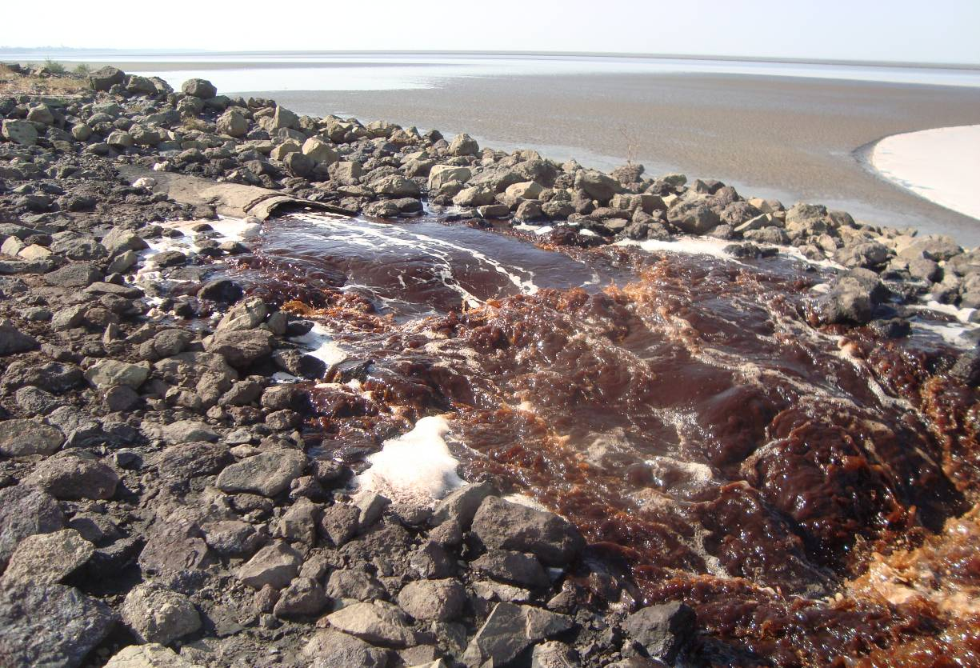

Photo-10

